**FIA Featured Coats for Kids Program– 2024/25 Supreme Matching Program**

**A Gift of warmth from the Knights of Columbus to a Child**

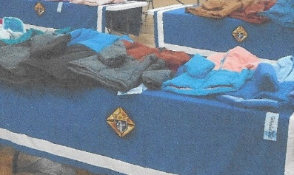

**Worthy Brothers in Christ**

**Great News…Supreme has extended the Coats for Kids matching program. The coats are available for Toddler (unisex style). All other Child, Youth and Teen sizes are available in both male and female styles . The price for the coats remains at $345.00 CA per case of 12 coats**

To qualify for the matching program, **Manitoba State must receive the** **council orders by Oct 19, 2024**. Manitoba State will submit the consolidated orders to Supreme office for approval of matching coat order. All the council orders for coats will be consolidated with the Supremes’ matching coats and shipped to Manitoba State for distribution

Last year 19 councils ordered coats for their local distribution. MB State received matching cases which were distributed on our behalf to First Nation Communities in Manitoba. We also received a late request for urgently needed coats from Fr. Dhana of Sacred Heart Church in Pukatawagon. With the assistance of the Archdiocese of Keewatin we were able to provide coats to the community with no additional transportation charges.

Orders must be emailed to MB State – [mbstkc@shaw.ca](mailto:mbstkc@shaw.ca) no later than **Oct 16**. Subject line should read **Coats for Kids** orders. And must include the following information:

* Local council name and contact person information including phone number
* **Order quantity** (How many cases of 12) **Size** (Toddler, Child, Youth, Teen) and **Gender** (M/F)
* Where you are planning to donate your coats and any special requests
* Include any media, parish or community coverage information
* Councils have **until Nov 1, 2022 to pay Manitoba State** for their coat orders
* MB State will place **all coat orders** … cheque should be made **to Manitoba State**
* MB State will advise where and when councils may pick up, but some alternative arrangements may be able to be make for rural councils
* Following your council’s donation of the coats complete form **10784.**

**Thank you** for your past/future support. Coats for Kids is a featured K of C Outreach Program helping families that do not have the resources to meet their child’s needs

Richard Carlyle , Program Director Manitoba State